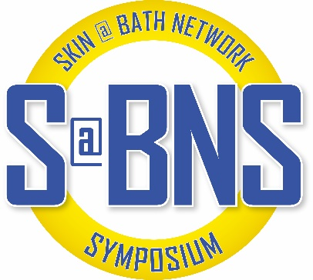
Skin@Bath Network Symposium
Wednesday 14th – Friday 16th December 2022 Bath, UK

Registration form
To reserve a place for you for the Skin@Bath Network Symposium, please complete the below registration form and return to BIRD@birdbath.org.uk to reserve your place.
Registration, dinner and/or hotel fees are to be made payable to BIRD to confirm your place, BACS details below.

Your details
Title |  |  | Mobile tel no
Forename |  |  | Email address
Surname |  |  | Dietary reqs
Role |  |  | Mobility reqs
Department
Organisation

Registration fees
 |  | Early bird Discount  Up to 1st October 2022 |  | Registration Fees  From 2nd October 2022
Non-Students/Non-Medical Trainees  (in person attendance) |  | ☐ | £135.00 | ☐ | £185.00
Students/Medical Trainees/Retired colleagues  (in person attendance) |  | ☐ | £55.00 | ☐ | £75.00
Accompanying person (in person attendance) |  | ☐ | £38.00 | ☐ | £58.00
Virtual attendance |  | ☐ | £75 per person | ☐ | £75 per person

Additional extras:
Weds 14th Welcome reception |  | ☐ | £0.00 Free of charge
Thurs 15th Evening reception including dinner |  | ☐ | £42.00 per person
Printed abstract/poster booklet |  | ☐ | £10.00 each

Hotel requirements
Travelodge  (Bath City Centre, 6-10 Westgate Buildings) |  | ☐ | 14th December (Weds)  £79.00 pp pn | ☐ | 15th December (Thurs)  £85.00 pp pn | ☐ | 16th December (Fri)  £125.00 pp pn
*Rate based on single occupancy. Deadline for hotel booking: 11th November 2022

Total amount due
£

BIRD BACS details
Account name | Bath Institute for Rheumatic Diseases |  | Bank | Unity Trust Bank
Account no | 20363439 |  | Sort code | 60 83 01
IBAN number | GB93 NWBK 6002 3571 4180 24 |  | SWIFT number | NWBK GB2L
Reference No | Please use the payment reference: D39 151222 and your surname
Foreign Payments - When making foreign payments to BIRD via Unity Trust Bank, the service is provided via NatWest or Western Union. Unity Trust only require the sort code and account number to be quoted when sending your payment with the IBAN & SWIFT numbers given above. Our sort code and account number are not included in our IBAN & SWIFT numbers.We cannot provide an alternative IBAN or SWIFT numbers - Further information here; https://www.unity.co.uk/banking-services/foreign-services/ ‘Receiving payments’ & ‘Important information about our Foreign services’. If you need any further information from us please don’t hesitate to get in touch.

Cancellation policy
Cancellations received before 1st October 2022 will receive a full refund.
Cancellations received before 1st November will receive a 50% refund for registration fees, unfortunately hotel cancellations cannot be refunded after 11th November 2022.
Cancellations received any later will not be eligible for a refund.
